**Evidence for Analysis and Design Unit.**

Your name here

Your Cohort

Date here

**AD - 1 Use case Diagram**

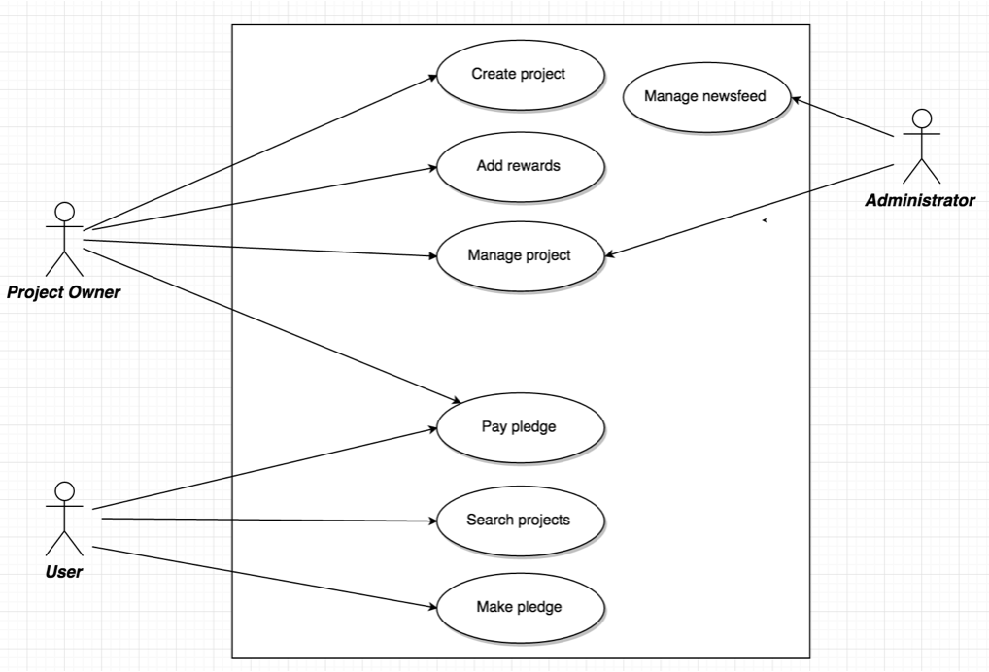

**AD - 2 Create a Class diagram using your Use case diagram.**

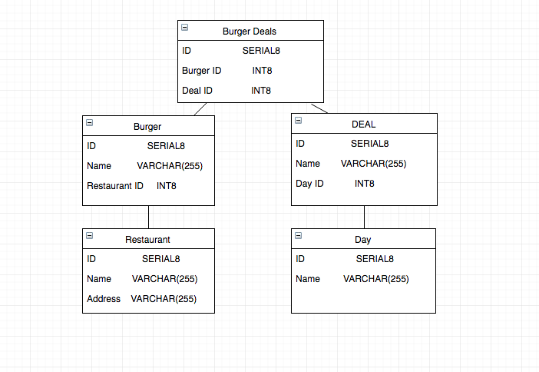

**AD - 3 Object diagram**

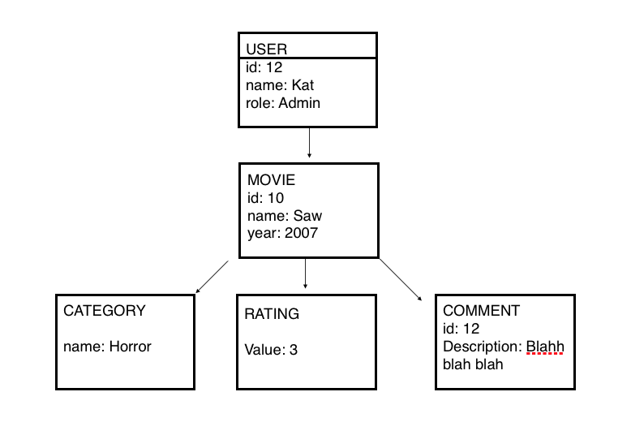

**AD - 4 Activity diagram**

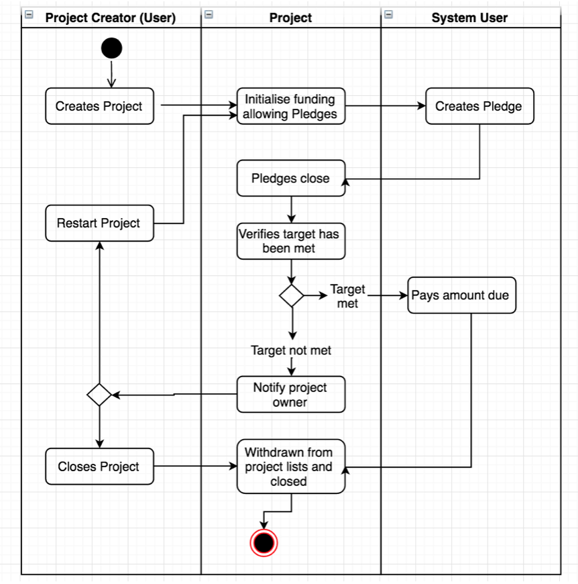

**AD - 5 Inheritance diagram**

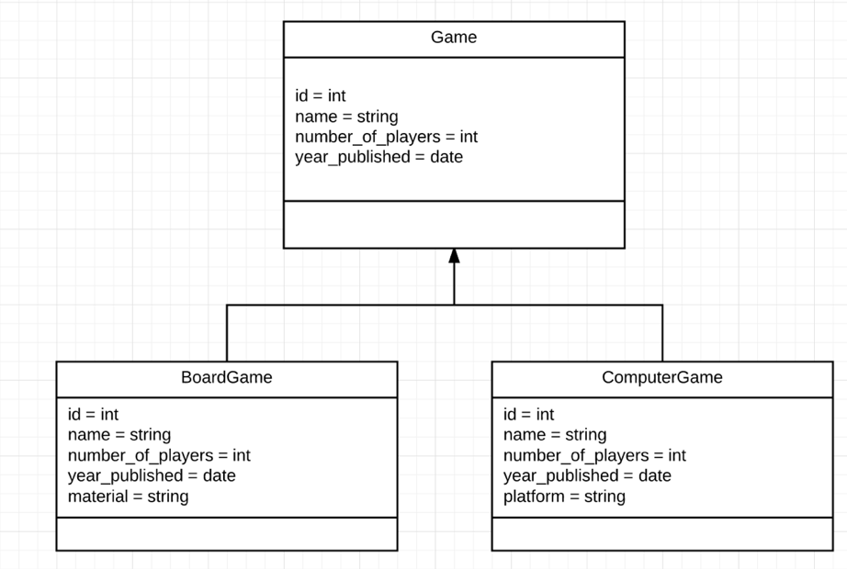

**AD - 6 Implementations Constraints**

|  |  |  |
| --- | --- | --- |
|  | **Constraint and possible effect** | **Solution** |
| **Hardware and software platforms** | What could be a constraint on the product.  How it could be a constraint of the product  Why is it a problem? | How the constraint will be avoided or how it is not a consideration. |
| **Performance requirements** |  |  |
| **Persistent storage and transactions** |  |  |
| **Budgets** |  |  |
| **Time** |  |  |